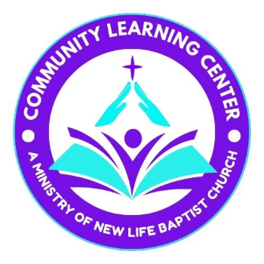
Community Learning Center
721 Ithaca Road, Spencer, NY 14883
(607) 589-2336

Application for Enrollment

Tuition Deposit: $75.00 per student
August 1-31st $100.00 per student
After September 1st - $125.00 per student

Office use only
Deposit paid: _____/_____/20___
Initials: ____________
Check # ____________ Cash____
Amount $ _____________

SECTION 1: Student Information

Name(s) of Children Sex Grade to Enter Date of Birth Age
______________ ________ ____________ _____________ ______
______________ ________ ______
______________ ________ _____________ ______
______________ ________ ____________ _____________ ______

SECTION 2: Family Information

Parents Names:__________________________________________________________________________________
Mailing Address: Home Number: __________________________________________
_______________________________________ Father Cell Number: ______________________________________
_______________________________________ Father’s E-Mail: __________________________________________
_______________________________________ Mother Cell Number: ______________________________________
Mother’s E-Mail: _________________________________________
Father’s or guardian’s employment: ____________________________________________________________________

Address: ________________________________________ Work Phone #:____________________________________

Mother’s or second guardian’s employment: _____________________________________________________________

Address:________________________________________ Work Phone #: _____________________________________
Person(s) other than parents/guardians to contact in an emergency:

Name: Number:

Name: Number:

Medical information:(label for specific child)
Doctor:_____________________________ Phone Number: _____-______-_______

Hospital (in case of emergency):__________________________________________

Allergies: ______________________________________________________________________

Medications (allowed to be administered at school): ______________________________________________________________________________

Medical conditions: ______________________________________________________________
As a condition of enrollment, I understand that: (please initial each)
[ ] 1. My child(ren) will go on scheduled field trips and other school activities.
[ ] 2. The tutor has full discretion in the classroom discipline of my child(ren).
[ ] 3. The administration has full responsibility for placing my child(ren) in the proper grade.

4. My cooperation is required in:
[ ] making regular tuition payments [ ] practical help
[ ] participation in hybrid homeschool functions
[ ] support of the tutors and hybrid homeschool
[ ] 5. The hybrid homeschool reserves the right to dismiss any student who does not respect its spiritual
standards or does not cooperate in the education process.
[ ] 6. In case of emergency when neither parent can be reached, I do hereby give permission for my
child to receive medical care, as necessary.
[ ] 7. I have received a copy of the school Handbook and agree to have my child abide by the rules
and standards of the school. I agree not to be divisive over CLC policies, rules, and standards.
[ ] 8. I understand that the latest CLC Parent Student Handbook are available in the Office and I
acknowledge I am responsible to read and have my child(ren) abide by the policies.
[ ] 9. I understand that by submitting this application I may be liable for all fees associated
with attendance and the first month’s tuition for registered children listed above.

SECTION 3: For New Families/Students Only:

Last School Attended: _________________________________________________________________________

Briefly explain why you are interested in sending your child to Community Learning Center:

Does your child have any special learning, health, or behavior concerns that we should know about?

CLC depends on parental volunteers to help with curricular and extracurricular activities. What areas of expertise to do you have that you would be willing to offer to CLC on a volunteer basis?

_______________________________________________________________________________________________________________

SECTION 4: photo release form for students: (mark which applies)
_______I agree to allow Community Learning Center to use my child(ren)’s photos for CLC related items, such as; brochures, flyers, PowerPoints, social media etc.
_______I do not agree to allow Community Learning center to use my child(ren)’s photos for CLC content.

Parent signature ________________________________________________________________________

Please understand that we use a Christian based curriculum, but our tutors will not be teaching a bible study. Any questions on curriculum are welcomed.

